{Insert Business Logo}
{Street Address}
{City State Zip}
{Phone Number | Website | Email}

Recurring Same-Day Direct Deposits Authorization Form

This is permission for recurring Same-Day Direct Deposits. As an authorized signor on the Depository Account presented, by completing and signing this form you give {Insert Business Name} permission to pay/credit your account for the amount indicated on or after the indicated date. This authorization is to remain in full force and effect until {Insert Business Name} has received written notification from me of its termination. **

Please complete the information below:

I ____________________________ as an authorized signor {Insert Business Name} to pay/credit my
(Full name)
account indicated below for $_____________ on or after ___________________. These payments are for
(Amount) (Date)

_____________________________________. My Account / Invoice Number is ________________________.
(Description of goods/services/on account)

Billing Address ____________________________ Phone# ________________________
City, State, Zip ____________________________ Email ________________________
Frequency: Weekly Monthly Annual basis, ____ Number of Payments

Depository Bank ___________________ Checking
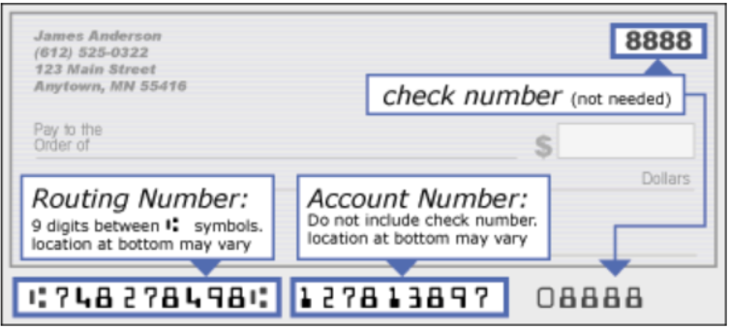
Routing Number ___________________ Savings
Account Number ___________________

I authorize {Insert Business Name} to pay/credit the account indicated in this authorization form according to the terms outlined above. This Same-Day Direct Deposit payment authorization is for the goods/services/account/invoice described above, for the amount indicated above and only for the occurrences indicated. I certify that I am an authorized signor on this Depository Account.

SIGNATURE DATE

Fax to: {Insert Business Fax} Scan & Email to: {Insert Business Email}

**I, ____________________________ hereby Revoke my Authorization for the payments/credits to the account. I understand that my right to place a stop payment exists only as long as I request and deliver this written stop payment notice at least three days prior to the scheduled settlement date.

Compliments of TodayPayments.com
We hope you find the payment authorization form useful.
Business Credit Cards and Payment Processing are our specialties ~

Need a Business Credit Card? - INSTANT DECISION!
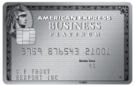  Business Platinum® Card  Apply Now Learn More |   Plum Card® from American Express  Apply Now Learn More | 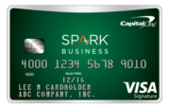  Capital One® Spark® Business Cash  Apply Now Learn More

Payment Processing
  Credit Card Processing  eCommerce Internet Sales  Mail Order Telephone Order  Retail Face-to-Face  Process Credit Cards at the Point of Sale  Mobile & Text Payments |   ACH Processing  Same-Day ACH deposit of your funds!  Online Reporting with Images  Stop Going to the Bank  Same-Day Funding  Mobile & Text Payments | 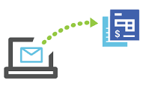  QuickBooks Invoicing  QuickBooks Enterprise  QuickBooks Pro  QuickBooks Premier  QuickBooks POS  QuickBooks Online

QuickBooks Accounting Software 