{Insert Business Logo}
{Street Address}
{City State Zip}
{Phone Number | Website | Email}

One-Time Same-Day Direct Payment Debit Authorization Form

This is permission for a single transaction only. As an authorized signor on the Depository Account presented, by completing and signing this form you give {Insert Business Name} permission to charge/debit your account, one-time, for the amount indicated on or after the indicated date. This authorization is to remain in full force and effect until {Insert Business Name} has received written notification from me of its termination. **

Please complete the information below:

I ____________________________ as an authorized signor {Insert Business Name} to charge/debit my
(Full name)
account indicated below for $_____________ on or after ___________________. This payment is for
(Amount) (Date)

_____________________________________. My Account / Invoice Number is ________________________.
(Description of goods/services/on account)

Billing Address ____________________________ Phone# ________________________
City, State, Zip ____________________________ Email ________________________

Depository Bank ___________________ Checking
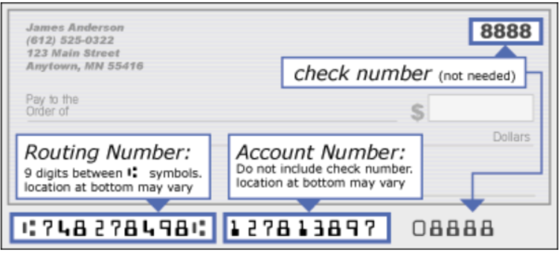
Routing Number ___________________ Savings
Account Number ___________________

I acknowledge that a minimum Non‐Sufficient Funds (NSF) fee of $25 may be charged by {insert business name} to me in the event there are insufficient funds available at the time the Same-Day Direct Payment is submitted. I authorize {Insert Business Name} to charge/debit the account indicated in this authorization form according to the terms outlined above. This payment authorization is for the goods/services/account/invoice described above, for the amount indicated above only, and is valid for one-time use only. I certify that I am an authorized signor on this Depository Account.

SIGNATURE DATE

Fax to: {Insert Business Fax} Scan & Email to: {Insert Business Email}

**I, ____________________________ hereby Revoke my Authorization for the charge/debit to the account. I understand that my right to place a stop payment exists only as long as I request and deliver this written stop payment notice at least three days prior to the scheduled settlement date.
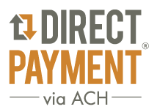
Compliments of TodayPayments.com
We hope you find the payment authorization form useful.
Business Credit Cards and Payment Processing are our specialties ~

Need a Business Credit Card? - INSTANT DECISION!
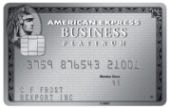  Business Platinum® Card  Apply Now Learn More |   Plum Card® from American Express  Apply Now Learn More | 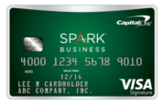  Capital One® Spark® Business Cash  Apply Now Learn More

Payment Processing
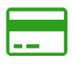  Credit Card Processing  eCommerce Internet Sales  Mail Order Telephone Order  Retail Face-to-Face  Process Credit Cards at the Point of Sale  Mobile & Text Payments |   ACH Processing  Same-Day ACH deposit of your funds!  Online Reporting with Images  Stop Going to the Bank  Same-Day Funding  Mobile & Text Payments | 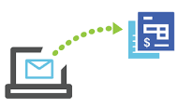  QuickBooks Invoicing  QuickBooks Enterprise  QuickBooks Pro  QuickBooks Premier  QuickBooks POS  QuickBooks Online

QuickBooks Accounting Software 